**WORK SHEET FOR PRACTICE-III**

**By Mr. Ajay Kumar**

1. Print the pattern below:

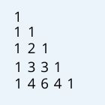 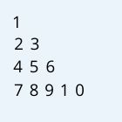

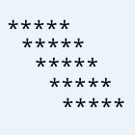 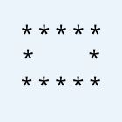

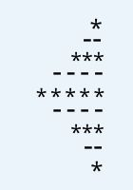 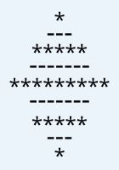

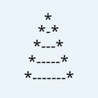 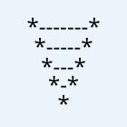

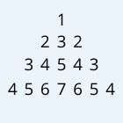 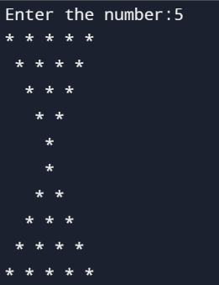

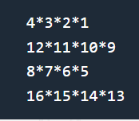 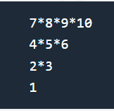

2. Which of the following operators are not allowed in Strings?

A. +

B. –

C.*

D.== ==

3.Write a Python program to remove characters that have odd index values in a given string.

4.Write a Python program to count the occurrences of each word in a given sentence.

5.Write a Python function to reverse a string if its length is a multiple of 4.

6.Write a Python program to check whether a string starts with specified characters.Like starts with @

Eg: input is @abnc it is valid but absn@ is no.

7.Write a program to find the number of vowels, consonents, digits and white space characters in a string.

**8.Write a code snippet that checks if a given string is a palindrome.**

9.Write a for loop that prints all even numbers from 10 to 20 in descending order.

* A. for i in range(10, 20, 2):
* B. for i in range(20, 10, -2):
* C. for i in range(10, 21, 2):
* D. for i in range(20, 10, -1):

10.What is the output of this code and how does it work?

numbers = [1, 4, 2, 5, 3]

for i in range(len(numbers)):

numbers[i] = numbers[i] * 2

print(numbers)

* A. It modifies the original numbers list, resulting in [2, 8, 4, 10, 6].
* B. It creates a new list with doubled values, but doesn't change the original.
* C. It iterates through a copy of the list, so the original remains unchanged.
* D. It throws an error because you can't modify a list while iterating over it.

11.Create a for loop that prints each character of "Hello, world!" on a separate line with its index.

* A. for i, char in enumerate("Hello, world!"): python print(i, char)
* B. for char in "Hello, world!": python print(char)
* C. for i in range(len("Hello, world!")): python print(i, "Hello, world!"[i])
* D. for i in "Hello, world!": python print(i)

12.What is the output of this nested for loop?

for i in range(3):

for j in range(2):

print(i, j)

* A. 0 0 0 1 1 1 2 2
* B. 0 1 1 2 2 3
* C. 0 1 2 3 4 5
* D. 1 2 3 4 5 6

13.What is the output of this code and how does slicing/concatenation work?

name = "Hard"

print(name[1:4] + name[0]

* A. "Hardb" - It extracts "ard" and adds "H"
* B. "arbd" - It extracts "ard" and keeps "H"
* C. "Hadr" - It extracts "Had" and discards "r"
* D. "ardH" - It extracts "ard" and appends "H"

14.What is the output of the following code?

for i in range(1, 7, 2):

print(i**2, end=" ")

* A. 1 9 25
* B. 2 4 8
* C. 1 3 7
* D. 0 1 2 3 4 5

15.What is the output of this nested for loop and how does it iterate?

for i in range(2):

for j in range(3):

for k in range(2):

print(i, j, k)

16. What does the len() function return when called on a string?

a) Total number of characters

b) Total number of words

c) Total number of lines

d) Total number of unique character

17. Which of the following methods is used to convert a string to lowercase in Python?

a) lower()

b) upper()

c) capitalize()

d) swapcase()

18. What is the result of "hello" + "world" in Python?

a) hello world

b) helloworld

c) hello, world

d) Error

19. Which method is used to find the index of the first occurrence of a substring in a string?

a) find()

b) index()

c) search()

d) locate()

20. Which escape sequence is used for a newline character in a string?

a) \n

b) \r

c) \t

d) \\

21. What will be the output ?

word = "programming"

for i in range(len(word)-1, -1, -2):

print(word[i], end=" ")

a) g i m r o p

b) g r m i n

c) g m a n

d) g r a m

22. What will be the output of the following ?

for i in range(10):

if i % 3 == 0 and i % 5 == 0:

print("FizzBuzz")

elif i % 3 == 0:

print("Fizz")

elif i % 5 == 0:

print("Buzz")

else:

print(i)

25. What will be the output of the following ?

text = "Python is fun!"

vowel_count = 0

for char in text:

if char in "aeiouAEIOU":

vowel_count += 1

print("Vowel count:", vowel_count)